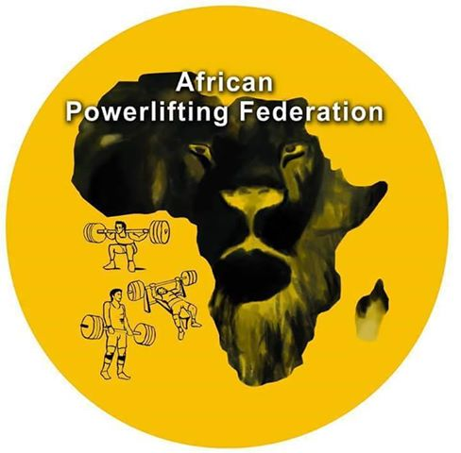
African Powerlifting Federation

Strategic Plan 2019-2022

Introduction

The African Powerlifting Federation under the umbrella of the International Powerlifting Federation effectively came into being in 1994. Since this time it has grown from a single nation to 14 member nations.
The development of the APF to where it is today has been a long road and many changes have taken place over the years. In alignment with IPF and following Olympic guidelines strict drug testing policies are in place in compliance with the World Anti Doping Agency (WADA). Rules have been adjusted and amended to make the sport safer for the lifter and more spectator friendly, Web site initiated, record systems are in place, equipment supplied to developing nations, training programmes and referee clinics are all in place.
The objective has been to grow Powerlifting throughout the whole of Africa to make it attractive and develop it into a popular sport for all that is safe, clean, fair and follows the highest ethical standards.
This Strategic Plan is a long-term plan and will be a guideline for all APF officials and member nations. All have the opportunity to work towards common goals, which will make the process more effective and transparent. Cooperation and support from all member nations is crucial if we shall reach our goals.
The APF faces many challenges in the future none more important than growing our member nations, which means more income. This allows us greater latitude to be able to provide more assistance to our existing and developing nations.
We need to focus on the quality of our competitions and become more professional in their application.
We need to provide more assistance to developing nations with equipment and training.
We need to get greater visual exposure to the African Powerlifting fraternity to make them aware that the APF is the premier Powerlifting organisation in Africa.
We all need to work together to achieve these goals.
Our Strategic Plan for 2019-2022 highlights the APF’s opportunities and challenges. The Strategic plan outlines our pathway to our long term goals. The 2019-2022 APF Plan document is relatively schematic. This serves to highlight the key issues the APF has to deal with and focus our work.
The APF aim to take an active role in shaping the future of powerlifting as part of IPF.

Outline of the Strategic Plan
- Introduction and summary
- Outline
- The core: our vision and mission
- The APF Mission
- Objectives and actions

The APF Vision
The APF will grow and continue to be the premier Powerlifting organization throughout Africa, will produce high quality competitions, high ethical standards, fair play and sport for all.

The APF Mission

Growth: Grow the sport throughout Africa
Fair Play: The APF will work for a clean, fair and true sport for all athletes and officials
Development: To educate and assist individuals and regional bodies to become better Powerlifters
Quality: To promote excellent, well run and efficient competitions
Promotion: To promote Powerlifting throughout Africa via various media channels

OBJECTIVES, GOALS AND ACTIONS

Mission 1: GROWTH

Objective: To grow Powerlifting throughout Africa
Goals to be achieved during the 2019-2022 period
- A net gain of 5 new member nations
Actions:
- Contact all African nations that were previously members who for some reason have withdrawn, to entice them back into the fold. Nations such as Congo, Nigeria, Kenya, Zambia, Botswana and Mauritius
- Create a team/sub-committee to approach sports commissions in targeted countries to make them aware of Powerlifting and the IPF and to elicit their help in establishing Powerlifting in their country. Invite these officials to attend regional and international championships.
- Stage familiarization / demonstration competitions and seminars in new countries. Invite one or two top Powerlifting athletes to give demonstrations.

Mission 2: FAIR PLAY

Objective: The APF will work for a clean, fair and true sport for all athletes and officials
Goals to be achieved during the 2019-2022 period:
- To ensure that the playing field is level for all athletes
Actions:
- Doping tests to be performed at all African championships
- Stimulate out of competition testing in cooperation with the IPF
- Create an organised plan for educational anti-doping seminars
- Organise anti-doping seminars in connection with African Regional and National championships
- Publish anti-doping news in media
- Work together with the IPF to maintain strong anti-doping rules
- Engender a spirit of fair play and sound ethical values

Mission 3: DEVELOPMENT

Objective: To educate and assist individuals and regional bodies to become better Powerlifters
Goals to be achieved during the 2019-2022 period:
- To increase the numbers of individual lifters and to provide good quality coaching and training for individuals and regions.
Actions:
- Utilise IPF allocated development funds available to provide rudimentary equipment (bars, weights, squat stands, benches) to developing nations. Make grants available to the president or designated official to attend major international championships to observe how a Powerlifting competition is organised and run.
- Make grants available to the head coach of each developing nation to attend the IPF coaching clinic in La Manga
- Send graduates from IPF coaching courses to developng nations
- Need to organise more regional competitions – perhaps zonal competitions, for example Southern African Championships (South Africa, Zimbabwe, Namibia)
- Organise coaching seminars one or two days before regional championships.
- Acquire coaching manuals from the IPF Coachig course to distribute to all APF nations.
- Encourage certification of Provincial, National and International referees from all APF nations

Mission 4: QUALITY

Objective: To promote excellent, well run and efficient competitions
Goals to be achieved during the 2019-2022 period:
- To achieve the same standard as IPF World Championships for all African Championships, for the benefit of all lifters and officials
Actions:
- APF Technical Director to determine suitability of venue – ie adequate warmup area, equipment (weights and bars) and facilities
- Lifting platform and equipment are up to IPF standard
- Spotters and loaders are competant
- Scorers, announcers and table officials are trained and competant
- Scoreboard available
- Adequate qualified referees are available
- Access to warmup area is controlled
- Backdrop to lifting platform to be of IPF standards for regional championships
- Refreshments are available for lifters and officials
- IPF rules regarding preliminary nominations, final nominations and weighins are followed

Mission 5: PROMOTION

Objective: To promote the sport of Powerlifting throughout Africa.
Goals to be achieved during the 2019-2022 period:
- To Increase visibility of African Powerlifting across all media channels
Actions:
- Make general media (National and regional newspapers) aware of forthcoming Powerlifting events
- Stage club demonstrations / competitions in popular populated venues such as shopping centres, malls, schools and allow public participaion. Invite the media to such events
- Promote top athletes sich as worlc champions to newspapers and magazines
- Live streaming of Powerliftng competitions from National to Regional championships
- Banners and posters to be displayed for all competitions
- Sponsorship to be encouraged
- Improve social media presence (APF Website, Facebook, Instagram, etc) for all APF nations

